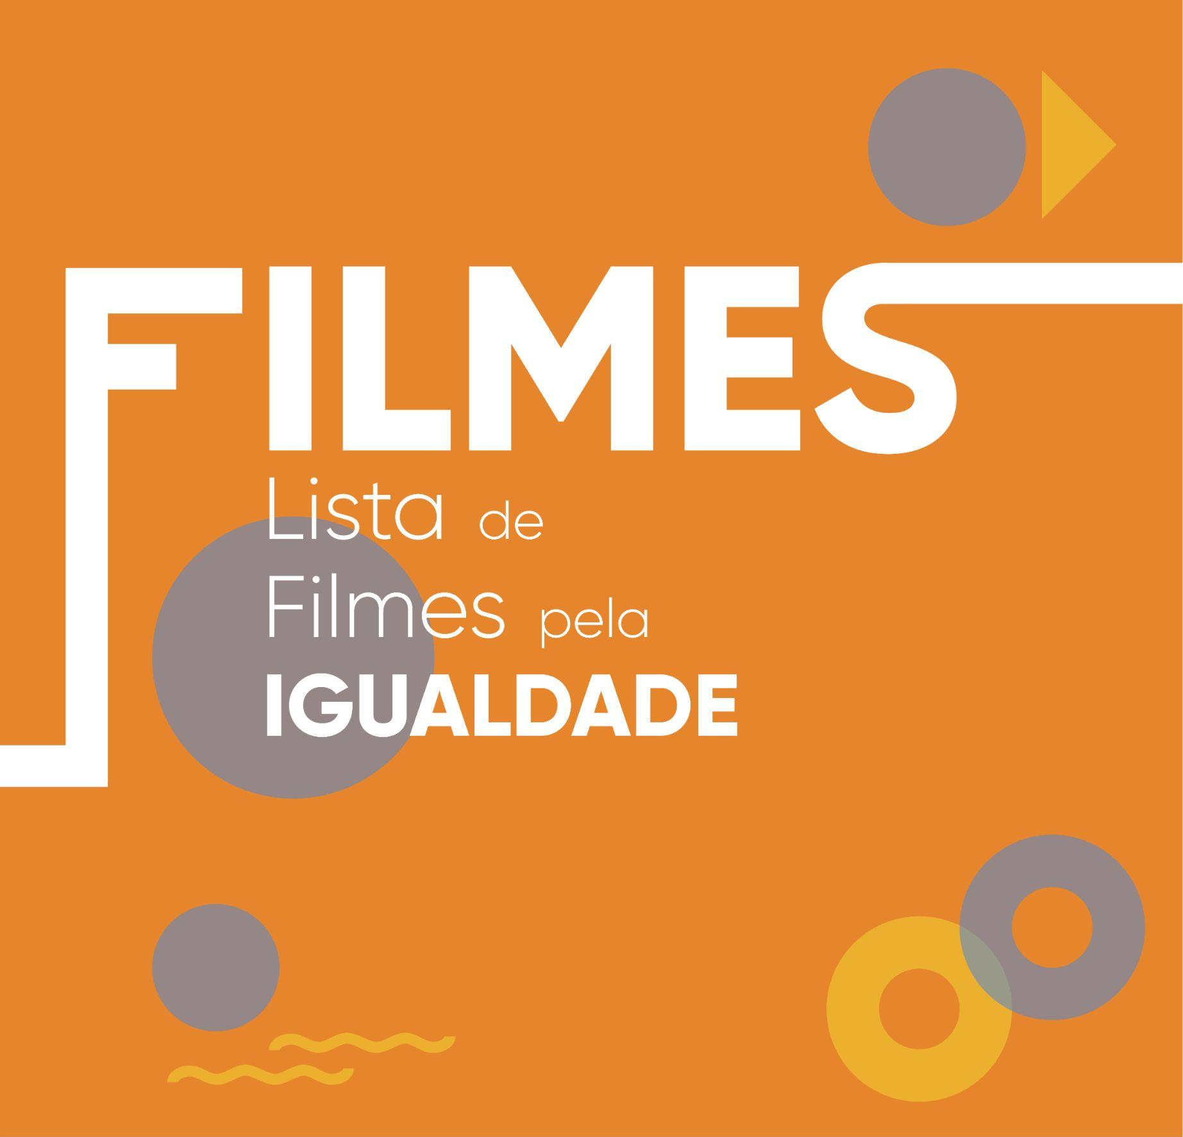

FILMES

Título | Link (Trailer)
Hidden figures (2016) / Elementos secretos | https://www.youtube.com/watch?v=kbmkRK1HC78
On the basis of sex / Uma Luta Desigual | https://www.youtube.com/watch?v=28dHbIR_NB4&t=1s
Wild (2014) | https://www.youtube.com/watch?v=tn2-GSqPyl0
A league of Their Own (1992)/ Liga de mulheres | https://www.youtube.com/watch?v=AwxfHCjNHv0
Whale Rider (2002) /  A Domadora de Baleias | https://www.youtube.com/watch?v=lvY24Qj6b78
Wendy and Lucy (2008) | https://www.youtube.com/watch?v=pASs3rerRCY
Queen of Katwe(2016) | https://www.youtube.com/watch?v=z4l3-_yub5A
Frida (2004) | https://www.youtube.com/watch?v=uOUzQYqba4Y
The Diary of a Teenage Girl (2015) /  "O Diário de Uma Rapariga Adolescente" | https://www.youtube.com/watch?v=PSnjJrbu1tY
Girlhood (2015) | https://www.youtube.com/watch?v=stR0B3P_zq8
Little Women /  Mulherzinhas | https://www.youtube.com/watch?v=AST2-4db4ic
Antonia’s Line (1995) | https://www.youtube.com/watch?v=3n1O-sKecdA
Raya e o último dragão (infantil) | https://www.youtube.com/watch?v=AgqAkKqGJRc
Moana (infantil) | https://www.youtube.com/watch?v=2Vz9xTjFbvw
Mulan (infantil) | https://www.youtube.com/watch?v=E6qDNGnw084
Wonder woman 1984 (Mulher maravilha 1984) | https://www.youtube.com/watch?v=erWairFYf6U
Dolores (2017) | https://www.youtube.com/watch?v=Unzr9kiFScQ
Campeões | https://www.youtube.com/watch?v=l_bjfPyErNs
Suffragette | https://www.youtube.com/watch?v=056FI2Pq9RY
“Persépolis” (2007) | https://www.youtube.com/watch?v=NZ22VyjJ6n8
Thelma & Louise” (1991) | https://www.youtube.com/watch?v=2iBFmKlO4BY
One sings, the other doesn’t | https://www.youtube.com/watch?v=JWLL1aFADUY
Marie Curie - The Courage of Knowledge (2016) | https://www.youtube.com/watch?v=ozIrVjgKMjI&ab_channel=MSPFilmSociety
The color purple (1985) | https://www.youtube.com/watch?v=HzGrDgu08r8&ab_channel=MovieclipsClassicTrailers
Made in Dagenham (2010) | https://www.youtube.com/watch?v=UHvz5kBkD0U&ab_channel=SonyPicturesClassics
Precious (2009) | https://www.youtube.com/watch?v=urFY3jp759c&ab_channel=LionsgateMovies
Brave (infantil) - 2012 | https://www.youtube.com/watch?v=5fPmKfcaaWk&ab_channel=MovieclipsComingSoon
Priscilla, a Rainha do Deserto (1994) | https://www.youtube.com/watch?v=75rguGiB1QQ
O Bom Nome (2006) | https://www.imdb.com/title/tt0433416/
Amigos Improváveis (2012) | https://www.mgfamiliar.net/blog/ai/
Que mal fiz eu a Deus? (2014) | https://www.youtube.com/watch?v=BEPMN-7aEAI
Call me by your name (2017) | https://www.youtube.com/watch?v=Z9AYPxH5NTM
SÉRIES

Título | Link (Trailer)
Borgen (2012) | https://www.imdb.com/title/tt1526318/
Big Little Lies (2017/2019) | https://www.indiewire.com/2019/07/big-little-lies-season-2-andrea-arnold-lost-creative-control-jean-marc-vallee-1202156884/
Histórias de São Francisco (2019) | https://www.reddit.com/r/television/comments/b303el/tales_of_the_city_gets_a_modern_twist_in_netflixs/
Feel Good (2021) | https://www.imdb.com/title/tt10098620/
The Bold Type (2020) | https://www.imdb.com/title/tt6116060/?ref_=nm_knf_t2
Mrs. America (2020) | https://www.goldderby.com/article/2020/mrs-america-fx-anna-boden-ryan-fleck-directors-video-interview/

