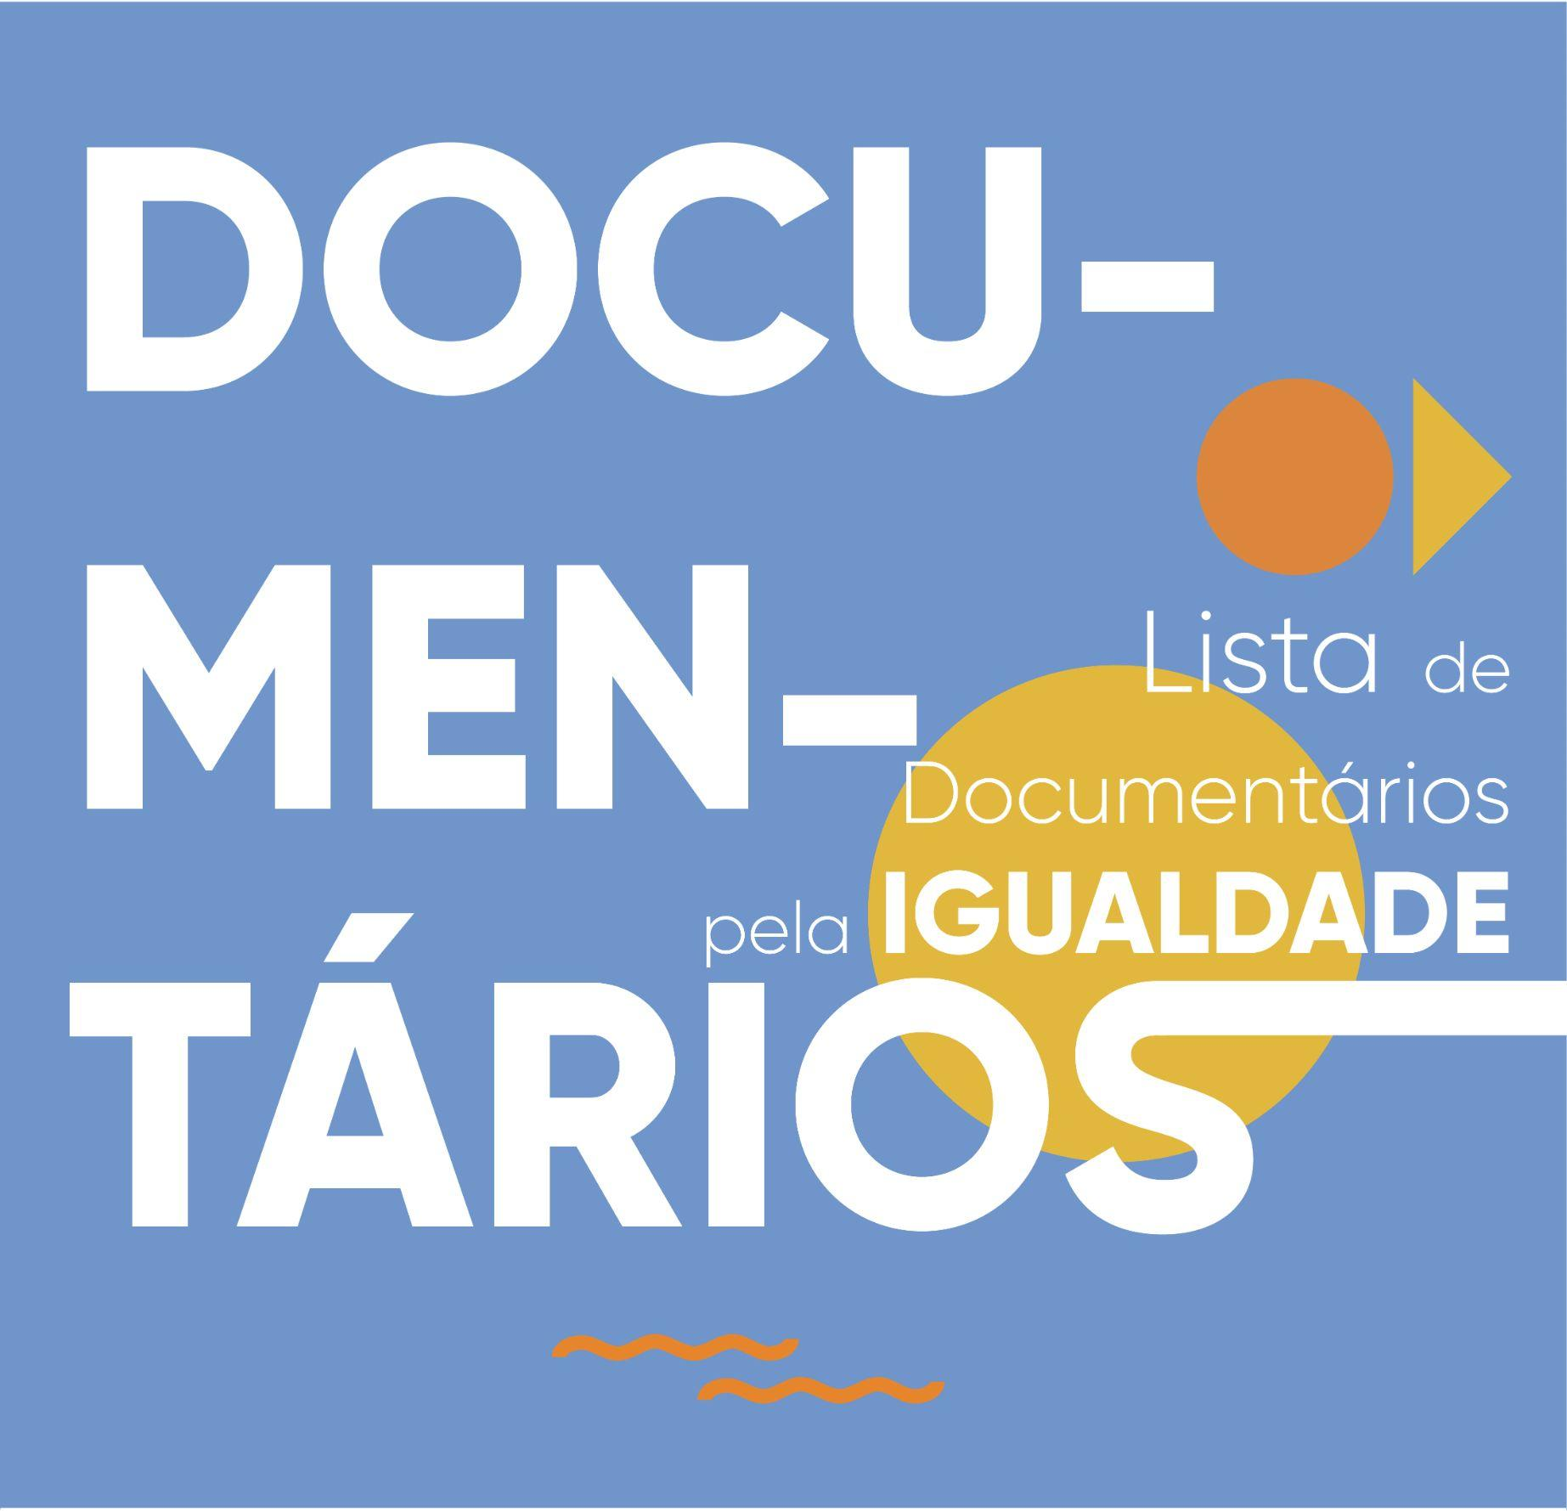

DOCUMENTÁRIOS

Título  (canção, artista) | Link
She’s beautiful when she’s angry (2014) | https://www.youtube.com/watch?v=6sUsLn7v_wI
Feminists: what were they thinking (2018) | https://www.youtube.com/watch?v=uAgeCLYnwNg
Libertem Angela Davis (2012) | https://www.youtube.com/watch?v=uBKhr3XYaN4
The punk singer (2013) | https://www.youtube.com/watch?v=zMbLzaVkn2s
Period. End of Sentence | https://www.youtube.com/watch?v=KocJP8dG1OA
Becoming | https://www.youtube.com/watch?v=wePNJGL7nDU
City of Joy | https://www.youtube.com/watch?v=MNy0MG_iy0Y
The Mask You Live In | https://www.youtube.com/watch?v=hc45-ptHMxo
Killing us softly | https://www.youtube.com/watch?v=jWKXit_3rpQ
Miss Representation | https://www.youtube.com/watch?v=W2UZZV3xU6Q
Chocó | https://www.youtube.com/watch?v=dw7fq_sp4jY
The true cost | https://www.youtube.com/watch?v=DjncKUmpOZk&t=10s
Histórias das mulheres do meu país | https://www.youtube.com/watch?v=nTs8ZvacqCE&ab_channel=RTP
Feministas, no que estariam a pensar? (2018) | https://www.netflix.com/pt/title/80216844
A Juíza (2018) | https://mubi.com/pt/films/rbg
Mulheres que desafiaram o congresso (2019) | https://pt.flixboss.com/filme/mulheres-que-desafiaram-o-congresso-81080637
A secret Love (2020) | https://www.imdb.com/title/tt3260524/

